**Reception Newsletter - Term 5**

**PE**

Our PE session will be on Thursday each week. Children will come to school in their PE kit, such as joggers or leggings with suitable footwear. This term we will be exploring how our bodies move. We will be discussing the effects of exercise on our body and our wellbeing.

**Phonics and Reading**

We will be sending home all of the taught graphemes and tricky words for your children to practice at home. This will support with fluency and developing their early reading and writing.

Junk Modelling

We are really enjoying creating our own models using a range of different sized boxes and containers, and we would welcome any donations of these items.

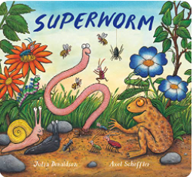 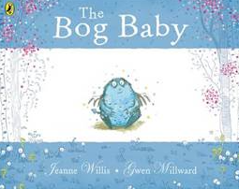

**Welcome back to the Summer Term!**

This term we will be exploring the topic of Mini-beasts. Our interest last term started to see us explore all of the different creatures in our garden. To extend this interest further, this term we will continue to learn about the different creatures we might find and will begin to explore the life cycles of these creatures. Some of the books we will be using as provocations will be The Hungry Caterpillar, What the Ladybird Heard and The Bog Baby. We will be using these books as slow reveals over each week. Our book to start this topic is Superworm.

Alongside this, we will continue to work on our phonics, using kinetic letters to form our letters and sentences and we will be exploring the mathematical concepts of numbers within 10. We have been developing our understanding of how to make numbers within 10, such as 8 can be made up of 5 and 3 or 4 and 4, and we are beginning to record this in writing.

In our independent learning, we will have the opportunities to develop our art skills through observational paintings and sketches. We will be scientists and use our skills to create a range of different homes for the bugs, as well as, exploring life cycles. Our home corner is a hospital, allowing us to act out several different roles and to demonstrate our school value of kindness. In our writing area, we will be developing our story writing, with opportunities to write our own books, captions and sentences using pictures from the book of the week, and even making up our own.

Thank you

The Reception Team

T

**Autumn term 1:** Thursday 3rd September – Thursday 22nd October