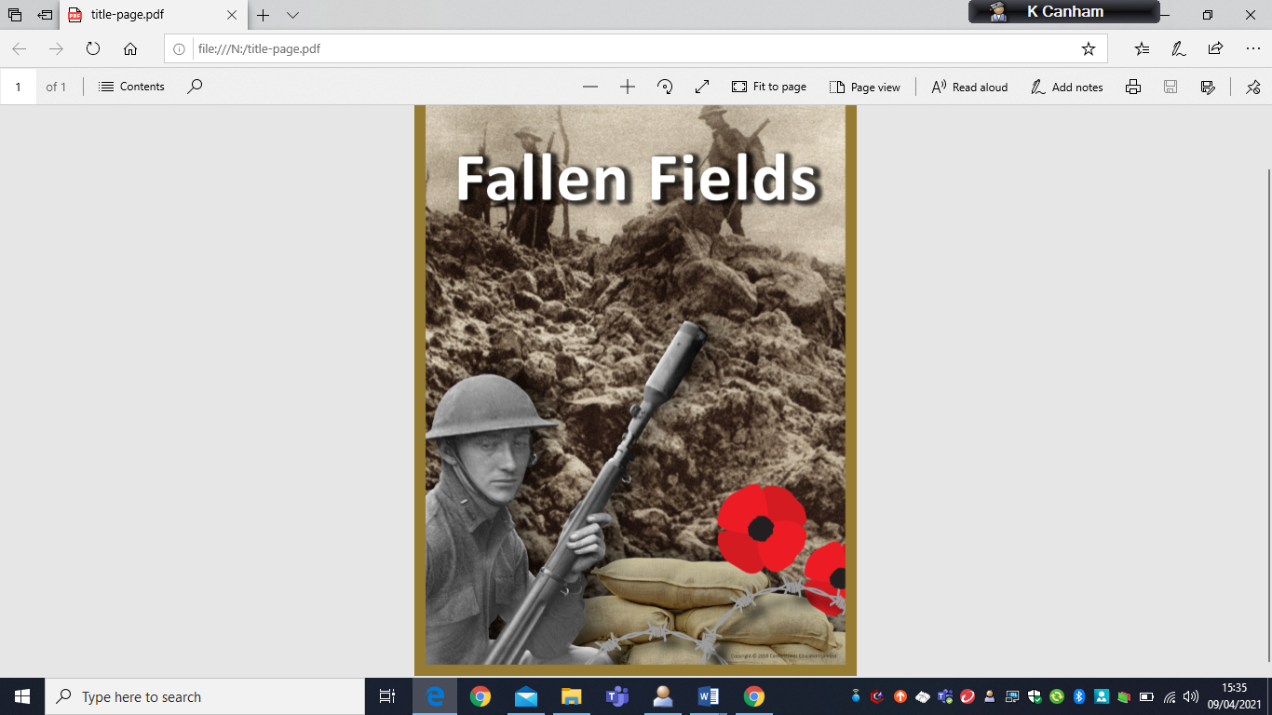

**Summer Term 1: Tuesday 19th April – Friday 27th May**

Dear Families,

We hope you have all had a relaxing Easter break. We are looking forward to welcoming the children back to school for the beginning of the summer term.

This term our topic is **Fallen Fields** and we will be learning about World War 1 through the themes of conflict and technology. We will be exploring how WW1 began, the enemies and allies, propaganda, the role of women in the home front, how the war ended and the Treaty of Versailles. Our English writing units will also continue with the theme of WW1 where we will be creating poetry inspired by Wilfred Owen and will write a dramatic scene from the war inspired by Michael Morpurgo novels. We will link the war topic further into science as we study materials.

As always, if you have any questions or concerns, please approach either one of the class teachers.

**Sensitivity of the war topic**

As we begin our topic centred around historical wars, we are mindful that questions and discussions about the current conflict in Ukraine may arise. Please contact your child’s class teacher if you have any questions or need support in navigating these queries.

**Healthy snack**

Please continue to provide healthy snacks (fruit) for your child’s playtime snack. Children should also bring a water bottle to drink throughout the day.

**Home learning**

Please continue to read daily as well as complete TT Rock Stars and spelling shed as frequently as possible. You should record in your child’s planner when you have read so that class teachers can track and offer prizes for consecutive weeks of reading.

**Year Five Newsletter - Term 5**



**Art and D&T**

Cottrell-Boyce class will be completing a D&T unit titled ‘Digital World’, using computers to assist the design and creation skills.

Bunzl class will be looking at an art unit on the artist’s intent, looking at art composition and how art is used to convey meaning and a movement.

**French**

French this term will be looking at the French speaking world, tying in their language skills with geographical links to the countries in the world that speak French.

**PSHE**

Our PSHE unit for this half term is **Citizenship**. We will look at the law, rights and responsibilities and how we can grow to become conscientious citizens who look after one-another and the planet. The unit finishes with understanding parliament.

**Physical Education**

Our PE unit this half term will prepare the children for Sports Day by practising athletics. The children will participate in sprinting activities, long distance running, hurdling and throwing events.

**Computing**

The children complete a unit on data handling, framed through the research data gathered by Mars Rover 1. Children will learn what binary code is and how binary creates sequences of number and text.

**Maths**

This term we will be finishing our **number** unit of decimals and percentages. We will then be moving on to our **geometry** where we will look at the properties of shape.

**English**

Writing sessions this term will focus on a poetry genre based on the war-time poetry of Wilfred Owen, focusing on capturing the tone and atmosphere of a serving soldier.

We will also write dramatic narratives based on the works of Michael Morpurgo, focusing on the relationships between the characters during the war.