Dear Families,

Welcome back! We hope you all had a lovely half term week and enjoyed the Jubilee celebrations. Our topic for this term is ‘Predators’.

This term we will learn about the animals including humans. We will be studying the importance of nutrition and what the different food groups are. The children will have the opportunity to carry out experiments using scientific equipment as well as taking part in STEAM Week where they will have assemblies and workshops with visitors. The children will also take part in a range of fun science, DT and art activities based around the royal family and the jubilee. We are looking forward to sharing all our learning with you during our class assemblies at the end of term.

Our Class reader this term continues to be Harry Potter and the Philosopher Stone.

If you have any questions, please feel free to talk to any one of us. We can all be contacted via Class Dojo.

Mrs Smith, Mr Baxter, Mrs Larrett and Mr Lynch

**PE**

Year 3 PE day is Tuesday. Please ensure that your child comes to school in their named PE kit on that day. Earrings need to be removed and long hair tied back for PE.

**Reading**

Please ensure that your child’s book bag, planners and reading book are in school every day.

**Water & Snacks**

It is crucial that every child arrives at school with fresh water in a named/labelled bottle. Please do not put water bottles inside book bags. Water bottles will need to be taken home at the end of every day. Please ensure your child has a healthy snack at break times. Thank you.

**ClassDojo**

We will use Class Dojo to communicate with you and to share the children’s learning. Please let us know if you still need to connect on this service and we will be able to give you a code.

**Homework**

Children will receive weekly Maths and English homework, including a weekly EdShed spelling list. This will be sent out on a Friday and needs to be returned by the following Wednesday.

**Year 3 Newsletter – Term 6**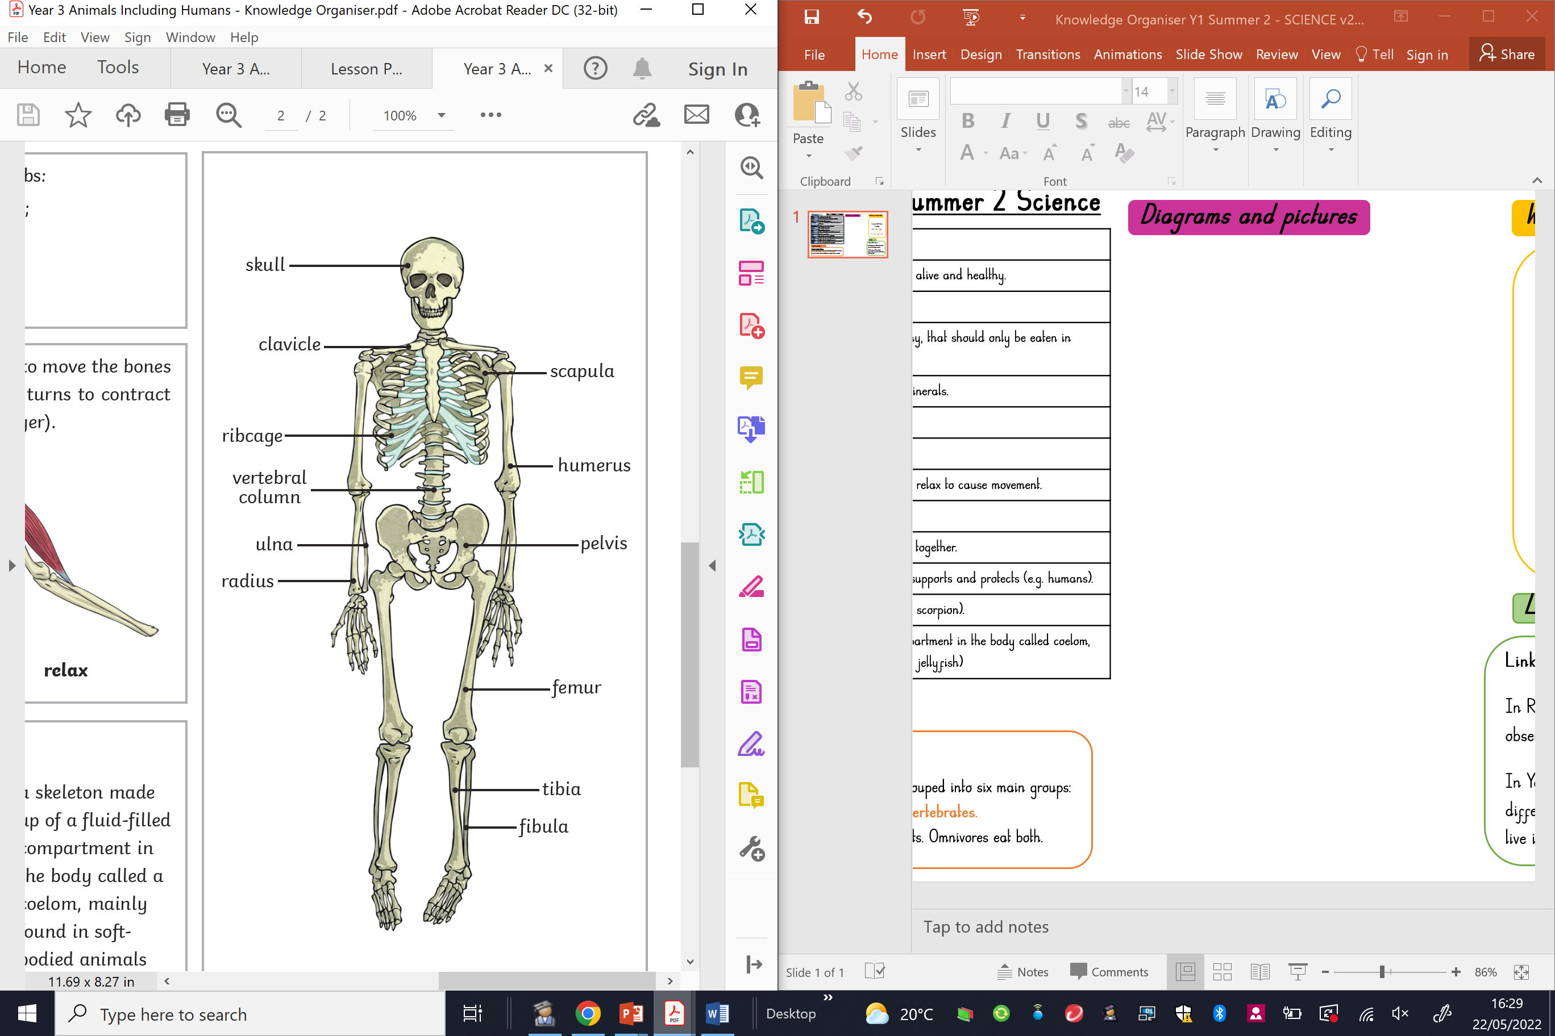

**Summer term 2:** Monday 6th June – Thursday 21st July 2022

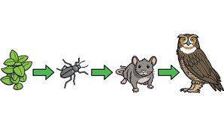

**English**

We will be focussing on adventure narrative, persuasive writing and non-chronological reports linked to our predators topic. This will allow the children to explore formats for both fiction and non-fiction texts and a range of persuasive techniques. Children will also be completing independent writing to pull together all the skills they have learnt this term. We will continue to cover spellings and grammar through using EdShed.

**Science**

The children will be learning about humans and living things. We will be looking at nutrition and sorting food into different groups. The children will also be learning about skeletons and muscles. We will carrying out an investigation based on how bones help us to move.

**Physical Education**

Children will be learning to play rounders including basic throwing and catching techniques. Developing team working skills and how to play a competitive sport with a specific set of rules. This will support the children’s ability to develop resilience.

**DT**

We will be completing a DT unit based on Digital World: Electronic Charm. The children will be designing a smart wearable and looking at the key features of a micro:bit for the eCharm.

**French**

In Year 3 we are learning about the circle of life in French. The children will be practising to say French animal nouns and sounds and also learning about French habitats and food chains.

**Computing**

During Computing lessons the children will be learning about e-safety using the National Online Safety scheme of work. Some of the units the children will be focussing on are managing online information, online bullying and privacy and security.

**Maths**

This term, we will be learning to tell the time, looking at properties of shapes and mass and capacity. The children will have the opportunity to use a range of concrete resources and measuring equipment. We will continue to develop our reasoning and problem solving skills.